June 26, 2023
Durham Region Chair
John Henry
The Regional Municipality of Durham
605 Rossland Road East
Whitby, Ontario L1N 6A3
john.henry@durham.ca
Re: Broadband improvement and Expansion in Durham
Dear Chair Henry,

The Whitby Chamber of Commerce is the largest Chamber in the Region and represents over 650 businesses in Whitby and the Durham Region. Considering the priorities and best interests of our membership (as highlighted by our annual survey), our Advocacy Committee aims to promote available resources and information on local broadband to our community and advocate for stronger and more reliable services.
We commend the intergovernmental collaborations which have resulted in how much we have accomplished thus far, including Durham Region being named one of the top 7 intelligent communities in the world in 2022, by the Intelligent Community Forum. Based on recent Regional budgets, we also appreciate the Region including pursuing federal and provincial Broadband funding opportunities. The Whitby Chambers requests that the Region continues to work with senior levels of government to seek additional funding to address the digital divide.
From our business community’s perspective, the lack of universally available truly high-speed Internet continues to impede businesses’ delivery of reliable customer service and hinder business growth and new business establishment. The Whitby Chamber’s 2023 Advocacy Survey identified broadband as a top 5 issue that demands “the most attention, time and resources” from the members and their business. Similarly, community consultation of the Town of Whitby’s 2022-26 Economic Development Strategy identified lack of broadband availability as a “weakness” to economic and development goals.
We understand that planned investments may resolve some of these challenges. Accordingly, the provision of more detailed timelines and project plans would help our community understand the roadmap and alleviate stressors from the “unknown”. Such detailed information would support successful strategic planning for economic growth.
To this effect, we would appreciate hearing from you on the below:

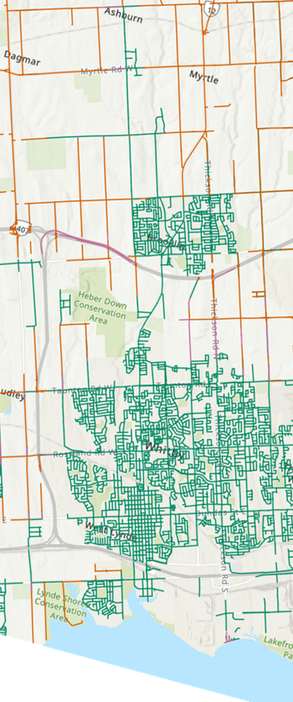
- What funding can the Region expect from the Province and Federal Government to support broadband expansion?
- When received, where will these funds be allocated? Specifically, what roadways in Whitby can expect investment?
- This Map of Whitby identifies “Pending government funded high-speed internet projects” in Orange, which highlight many of Whitby’s rural roads, where many of our small and local businesses operate. What is the next stage for broadband execution for these locations? When can these areas expect to have reliable access to highspeed Internet?
- What is the Region doing to support sustainable and affordable access to internet?
We look forward to the information you can share. We know our members and Committee would greatly appreciate it.
Durham and Whitby are bound for greater success, and integral infrastructure will be necessary to build on our momentum.
Sincerely,
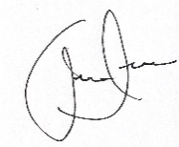
Andrew Scuse, President
Whitby Chamber of Commerce

CC:
Elizabeth Roy Mayor of Whitby
Dave Barton Mayor of Uxbridge and Chair of the Regional Works Committee

