June 12, 2023

Honourable Kinga Surma  Ontario Minister of Infrastructure  Ministry of Infrastructure  5th Floor, 777 Bay St.  Toronto, ON, M7A 2J3  Kinga.Surma@pc.ola.org | Durham Region Chair  John Henry  The Regional Municipality of Durham  605 Rossland Road East  Whitby, Ontario L1N 6A3  [email]

Re: Broadband expansion and strengthening in Durham

Dear Honourable Ms. Surma and Chair Mr. Henry,

The Whitby Chamber of Commerce is the largest Chamber in the Region and represents over 650 businesses in Whitby and the Durham Region. Considering the priorities and best interests of our membership (as highlighted by our annual survey), our Advocacy Committee aims to promote available resources and information on local broadband to our community and advocate for stronger and more reliable services.
We commend the intergovernmental collaborations which have resulted in how much we have accomplished thus far, including Durham Region being named one of the top 7 intelligent communities in the world, by the Intelligent Community Forum. Based on recent budgets, we also appreciate that broadband investments are a high priority for both the Regional and Provincial governments.
From our community’s perspective, the broadband shortages continue to interrupt reliable customer service and hinder economic success, especially for small businesses. Our 2023 Advocacy Survey identified broadband as a top 5 issue that would “draw the most attention, time and resources” from the members and their business. Similarly, the Town of Whitby’s 2022-26 Economic Development planning included a SWOTA exercise, where broadband availability was identified as a “weakness” to the economic and development goals.
We understand that much of these challenges are on their way to being resolved. Accordingly, providing more detailed timelines and sustainable project plans can help our community understand the roadmap and alleviate stressors from the “unknown”. This information supports successful strategic planning for economic growth.
To this effect, we would appreciate hearing from you on the below:
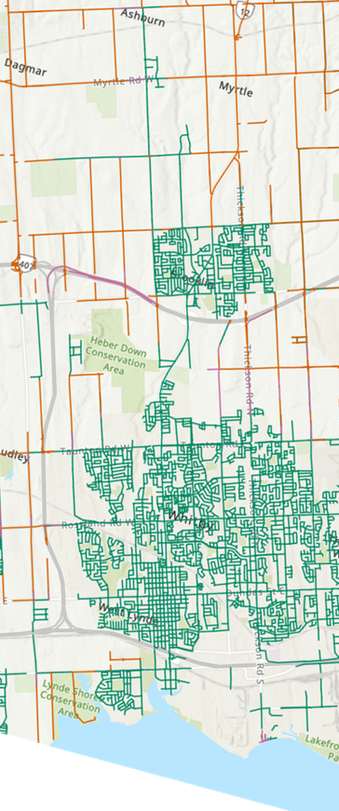
- What funding can the Region expect from the province (and Federal Government) to support broadband expansion?
- When received, where will these funds be allocated? Specifically, what roadways in Whitby can expect investment?
- This Map of Whitby identifies “Pending government funded high-speed internet projects” in Orange, which highlight many of Whitby’s rural roads, where many of our small and local businesses operate. What is the next stage for broadband funding and execution for these locations? When can these regions expect to have reliable access to highspeed internet?
- When highspeed internet is available, what tools are available to the governments to reduce or maintain internet costs, and promote market competition?
- Appreciating the integral need for high-speed internet to participate in the community, school, workplace, etc.; what steps have been taken to publicly fund high-speed internet?

We look forward to the information you can share. We know our members and Committee would greatly appreciate it.
We know Durham and Whitby are bound for greater success, and integral infrastructure will be necessary to build on our momentum.
Sincerely,
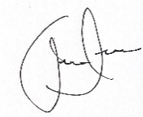
Andrew Scuse
President
Whitby Chamber of Commerce

CC:
Member of Parliament, Ryan Turnbull
Member of Provincial Parliament, Lorne Coe
Mayor, Elizabeth Roy

